
LESSON NOTE | DETAILED EXPLANATORY NOTES
HEALTH AND MEDICAL BIOLOGY
SYSTEMIC RESPONSE TO DISEASE OR INJURY

GRADE 12 - BIOLOGY
■ ■ ■

What is the Systemic Response to Injury?
When the body is injured or invaded by microorganisms, it mounts a coordinated defence to repair the damaged tissue, destroy invading microbes, and restore homeostasis. A small, local injury is usually repaired with little disturbance. A major injury or serious infection, however, triggers a systemic (whole-body) response involving the nervous, hormonal and immune systems working together.
Understanding how this response is switched on and, just as importantly, switched off explains how the body heals - and how doctors can help when the response is too weak or too strong.
Two Phases of the Response
- Pro-inflammatory phase - cellular processes are activated to restore tissue function and eradicate invading microorganisms.
- Anti-inflammatory (counter-regulatory) phase - important for preventing excessive inflammation and for restoring homeostasis.
Systemic Response to Disease or Injury
Key Learning Outcomes
By the end of this lesson, students should be able to:
- Describe how the body responds to disease processes or injuries.
- Explain the inflammatory response and its purpose.
- Distinguish the pro-inflammatory and anti-inflammatory phases of the response.
- Describe how the nervous system controls inflammation by reflex.
- Describe the hormonal and immune/cellular responses to injury.
- Explain how the response works to restore homeostasis.
The Inflammatory Response
Inflammation is the body's first, local response to injury or infection. Damaged cells and immune cells release chemical mediators (such as histamine and cytokines). These make nearby blood vessels widen, increasing blood flow and allowing immune cells to reach the site. This produces the familiar signs of inflammation - redness, heat, swelling and pain - while the immune cells fight microbes and the tissue is repaired.
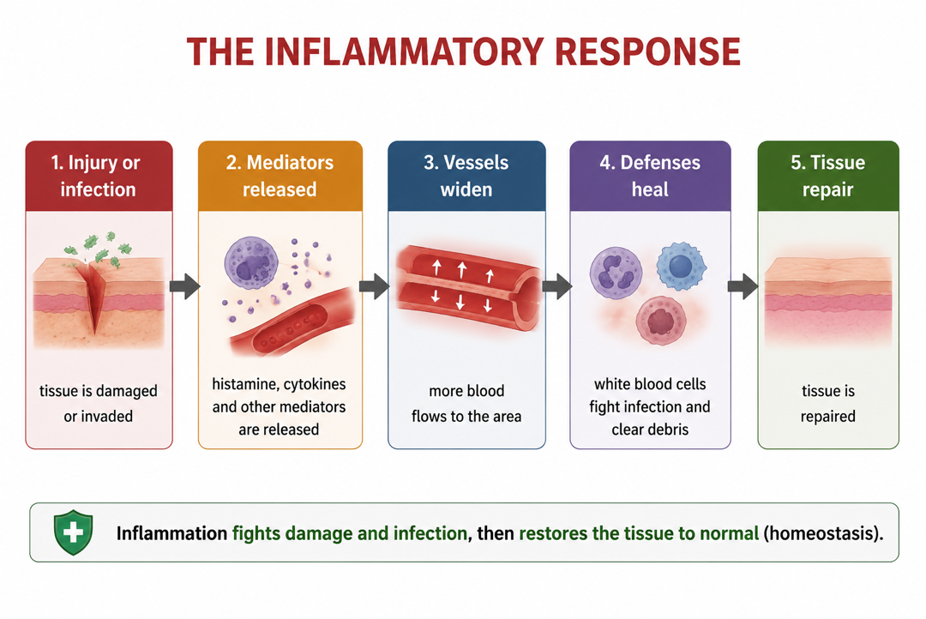
Figure 1: The inflammatory response - local injury triggers mediators, blood flow and immune cells that repair the tissue.
Terminologies and Concepts
Understanding the systemic response requires familiarity with several key terms:
- Inflammation: the body's local response to injury, with redness, heat, swelling and pain.
- Systemic response: a whole-body response involving the nervous, hormonal and immune systems.
- SIRS (Systemic Inflammatory Response Syndrome): an overwhelming, whole-body inflammatory response.
- Immune cells (immunocytes): cells such as macrophages and T-helper cells that defend the body.
- Cytokines: signalling molecules (e.g. TNF) that immune cells use to coordinate inflammation.
- Glucocorticoids (cortisol): stress hormones that help control inflammation and mobilise energy.
- Vagus nerve / acetylcholine: the nerve and neurotransmitter of the anti-inflammatory reflex.
Local versus Systemic Response
A local injury of limited size is usually followed by full recovery with little intervention. But a major injury or serious infection can set off an overwhelming, whole-body inflammatory response - Systemic Inflammatory Response Syndrome (SIRS) - which, without timely treatment, can lead to multiple organ failure and threaten survival. The body therefore balances two phases: a pro-inflammatory phase that fights the threat, and an anti-inflammatory phase that controls the reaction and restores homeostasis.
How the Nervous System Controls Inflammation
The body controls inflammation partly by a reflex, much like the knee-jerk reflex. Inflammation at an injury site sends afferent signals (carried by cytokines such as TNF, and by nerves) to the brain (hypothalamus). The brain rapidly relays opposing anti-inflammatory messages back to the site through the vagus nerve, which releases acetylcholine and reduces the release of inflammatory mediators by immune cells. This cholinergic anti-inflammatory pathway is fast and precisely targeted at the injury.
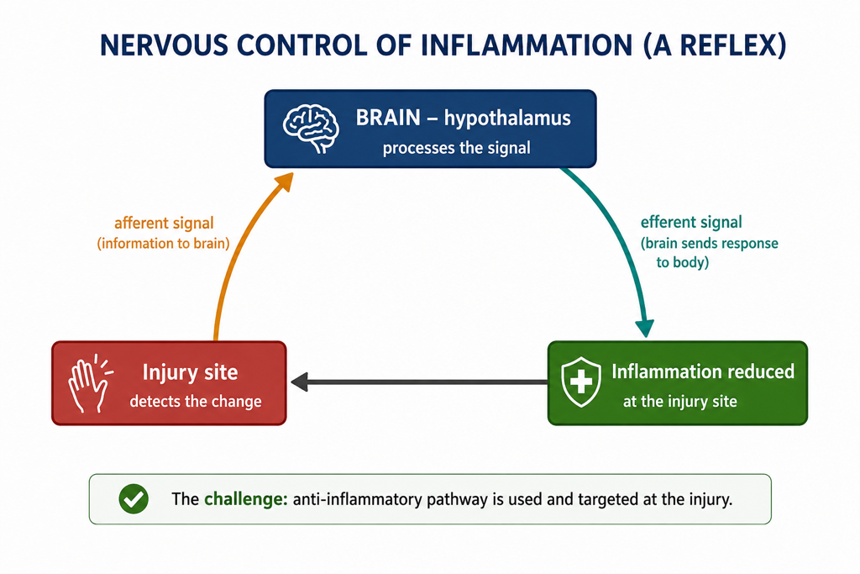
Figure 2: A neural reflex - the brain detects inflammation and sends anti-inflammatory signals via the vagus nerve.
The Hormonal Response to Injury
Injury also triggers a hormonal stress response. The hypothalamus signals the pituitary gland to release ACTH, which makes the adrenal glands release glucocorticoids (cortisol); the sympathetic nervous system releases adrenaline. Glucocorticoids enter cells and bind to receptors that travel to the nucleus and change gene expression, helping to calm inflammation, while adrenaline and cortisol mobilise energy (raising blood glucose) so the body can respond to the injury. Together these hormones support recovery and help restore homeostasis.
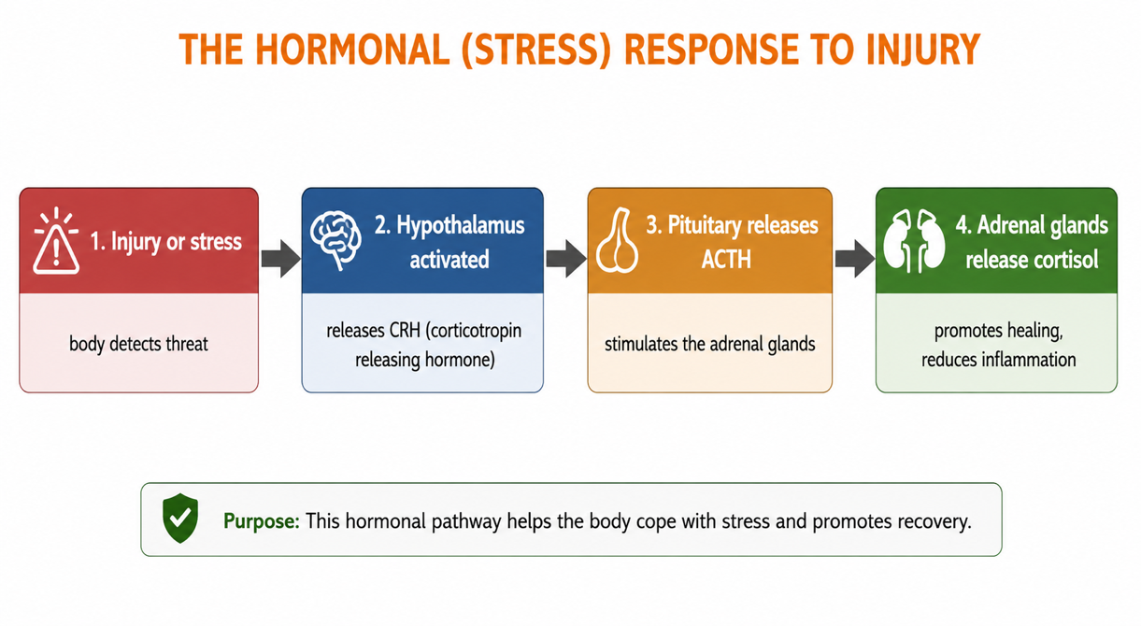
Figure 3: The hormonal response - ACTH triggers cortisol and adrenaline, which control inflammation and mobilise energy.
The Immune and Cellular Response
At the cellular level, immune cells lead the defence. Macrophages engulf microbes and release cytokines that call in more defenders. T-helper cells (types TH1 and TH2) coordinate the wider immune response. Inside the responding cells, gene expression changes so that defensive proteins are made. Once the threat is cleared, the anti-inflammatory phase switches the response off and the body returns to its normal, stable state.
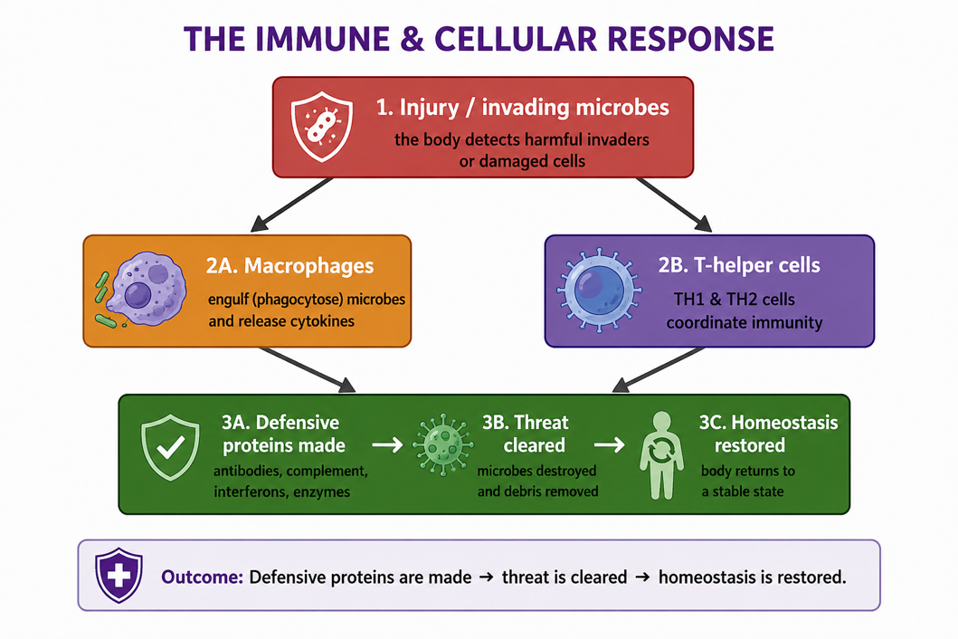
Figure 4: The immune and cellular response - macrophages and T-helper cells clear the threat and restore homeostasis.
Restoring Homeostasis
The whole point of the systemic response is to restore homeostasis after injury or infection. The pro-inflammatory phase removes the threat and repairs tissue, while the anti-inflammatory phase prevents the reaction from becoming harmful and returns the internal environment to normal. When this balance fails - too little response, or an uncontrolled response such as SIRS - disease and even organ failure can result, which is why medical care aims to support and balance the body's own response.
Worked Example - The Body's Response to a Wound
Situation: a person cuts their hand and bacteria enter the wound.
- Injury: tissue is damaged and microbes invade.
- Inflammation: damaged and immune cells release mediators; vessels widen; the area becomes red, hot, swollen and painful.
- Immune response: macrophages engulf bacteria and T-helper cells coordinate the defence.
- Control: the brain (via the vagus nerve) and hormones (cortisol) keep the response in check.
- Recovery: the threat is cleared, the tissue is repaired, and homeostasis is restored.
Each system - nervous, hormonal and immune - plays its part, and the anti-inflammatory phase ensures the response does not become harmful.
Why This Matters
- Healing - the systemic response is how the body repairs injury and fights infection.
- Medicine - surgery and treatments must support, not overwhelm, the body's response.
- Serious illness - an uncontrolled response (SIRS, sepsis) can cause organ failure and must be treated quickly.
- Homeostasis - it shows how the nervous, hormonal and immune systems cooperate to restore balance.
PNG Context Example
In Papua New Guinea, the body's response to injury and infection is central to managing common health problems - wound infections, malaria (where fever is part of the response), and recovery after surgery in hospitals and health centres. Health workers watch for signs of inflammation and for a response that becomes too strong (sepsis), treating infections early so the body's own defences can restore homeostasis.
References & Related Documents
Source Documents
- STEM Biology Student Resource Book - Grade 12, Term 1. Module 12.1 Health and Medical Biology, Topic 3: Systemic Response to Disease or Injury (Inflammatory Response; SIRS; Neural & Hormonal Control; Cellular Response). Department of Education, PNG (2021).
- STEM Biology Syllabus - Grade 12, Term 1. Topic 3: Systemic Response to Disease or Injury.
- Biology Standards-Based Syllabus, Grades 11 & 12 (PNG SBC 2020) - Strand 2: Life; Grade 12 evidence outcome on how homeostatic balance occurs in cells and organisms.
Further Reading & References
- OpenStax Anatomy & Physiology - The Immune System; Inflammation. https://openstax.org/books/anatomy-and-physiology
- Khan Academy - The immune system; the inflammatory response. https://www.khanacademy.org/science/biology

